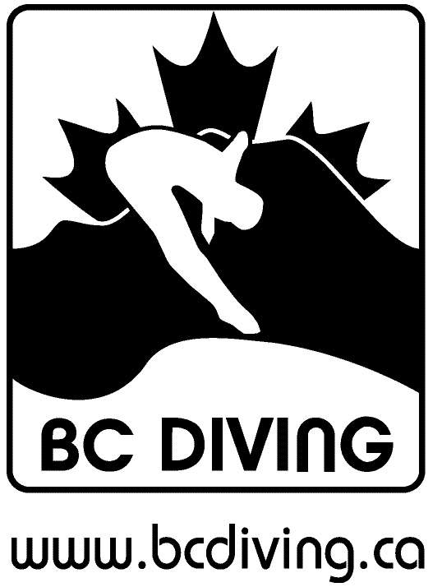
CANADIAN AMATEUR DIVING ASSOC. INC (BC SECTION)
Proposed Registration Fees to be effective September 1, 2017

Membership Category | 2016 Fee | Proposed Fee 2017
Learn to Dive | $ 16 | 17
Learn to Dive Trial* (New) | 5 | 5
Learn to Dive Group Trial | 1 | 1
Recreational | 37 | 37
Masters | 37 | 37
Competitive Provincial Jr/Sr. | 92 | 92
Competitive National Jr./Sr. | 122 | 122
Unattached | 145 | 145
Associate | 6 | 6
Officials | 36 | 36
Coaches (National standard) | 82 | 82
Coaches/Instructors | 42 | 42
*Club Fee (as per registration policy) | 115 | 200

