**ARM SWINGS AND TAKE-OFFS**

**Arm Swings –**

Start from Ready Position

1. Big arm-swing stopping briefly at the top in fully extended reach position. (Make sure that the arms are straight, not bent at elbows. Relax the shoulders in the swing, and let the arms swing through fast and fluid.
2. 8 forward and 8 backward

**Top to Top or TYO Jumps –**

Start from Ready Position

1. Arms up to reach or Y position and raise up on toes
2. Drop – bend at knees and heels down (shoulders, hips, and heels in line, do not lean forward)
3. Swing arms down and back up coming down the side and up the front
4. Push from legs and feet jumping**\*** up and landing with arms in reach position

Repeat 8 times starting slow; stop at each step, then progress faster.

2-step Swing and a Jump (Start from Ready Position)

1. Arms up to reach and raise up on toes
2. Arm Swing/Drop and a Jump**\***, landing and holding the reach position

Repeat x 8.

**\*This skill can be done by substituting a Full Extension to Reach instead of a Jump to minimize noise on floor.**

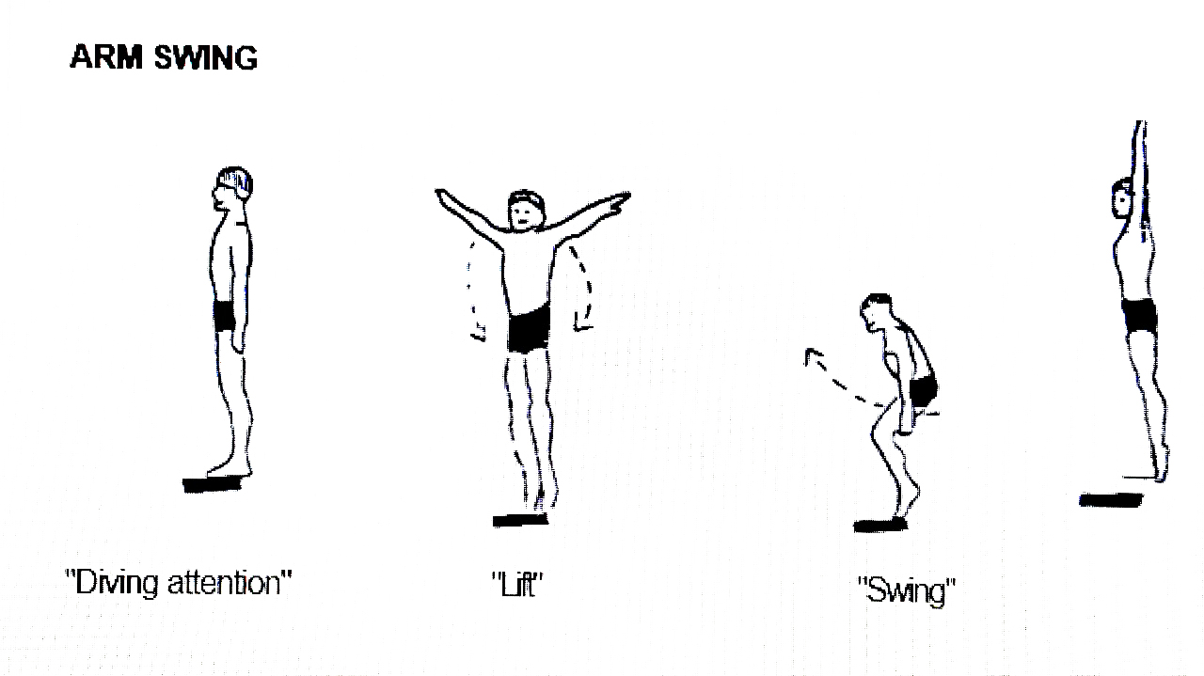

**This at Home Workout is designed so that it can be done in a small space with minimal noise to neighbours.**

**Don’t do jumps if you’ll hit your ceiling or disturb neighbours!**

**READY POSITONS**

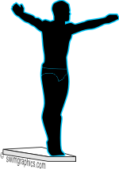

**(Diver attention/Body check)**

* Standing tall
* Feet together
* Legs straight
* Tummy and Buttocks tight
* Shoulders square and relaxed
* Arms straight and by side or out to a “T”
* Fingers together and hands straight
* Head neutral
* Eyes focused on ground @ 5 feet in front

**Head to Toe Warm-up**

* Head/Neck
* Shoulders/Arms
* Hips
* Knees
* Ankles/Wrists

**ENTRIES –** Repeat each 8 - 12 times starting slow, stop at each step, then progress faster

**Pike**: Start from a Reach Position

1. Touch toes,
   1. bending at the waist, knees straight, arms straight and down the front,
2. Arms to a “T”
   1. Eyes should be on knees or toes
   2. Arms should be straight and hands just visible to eyes, not behind head
3. Out
   1. Standing straight, arms still at a “T” with little arm movement
4. Close and stretch

**Open Pike:** In step one the arms start by coming down the middle, then in an arc open to a “T”

**Closed Pike:** In step one the arms come faster, straight down the front, wrapping around the legs behind the knees, head down and looking at knees, squeeze pike

**Tuck**: Start sitting on a mat in Tuck Position, heels off mat and toes pointed, hands grabbing half way on shines and eye looking over knees.

1. - Tuck
2. - Kick
3. Back flat on mat, heels off mat, arms straight and hands on top of thighs, eyes looking at toes
4. - Look
   1. Shoulders flat to mat, chin up looking back.
5. - Stretch for the entry

**This can also be done from standing.**

1 – From Reach, drop to a tuck grabbing shins, butt close to the ground, and looking at feet.

2 – Kick to an Entry Stretch, arms coming narrow up the front.

**Layout/Straight**: Start from ready position

1. Arms to a “T”
2. Look up raising chin slightly
3. Close and stretch
   1. Entry grab, arms straight and squeezing ears, up on toes and looking just in front of thumbs
4. Repeat starting at the “T” position

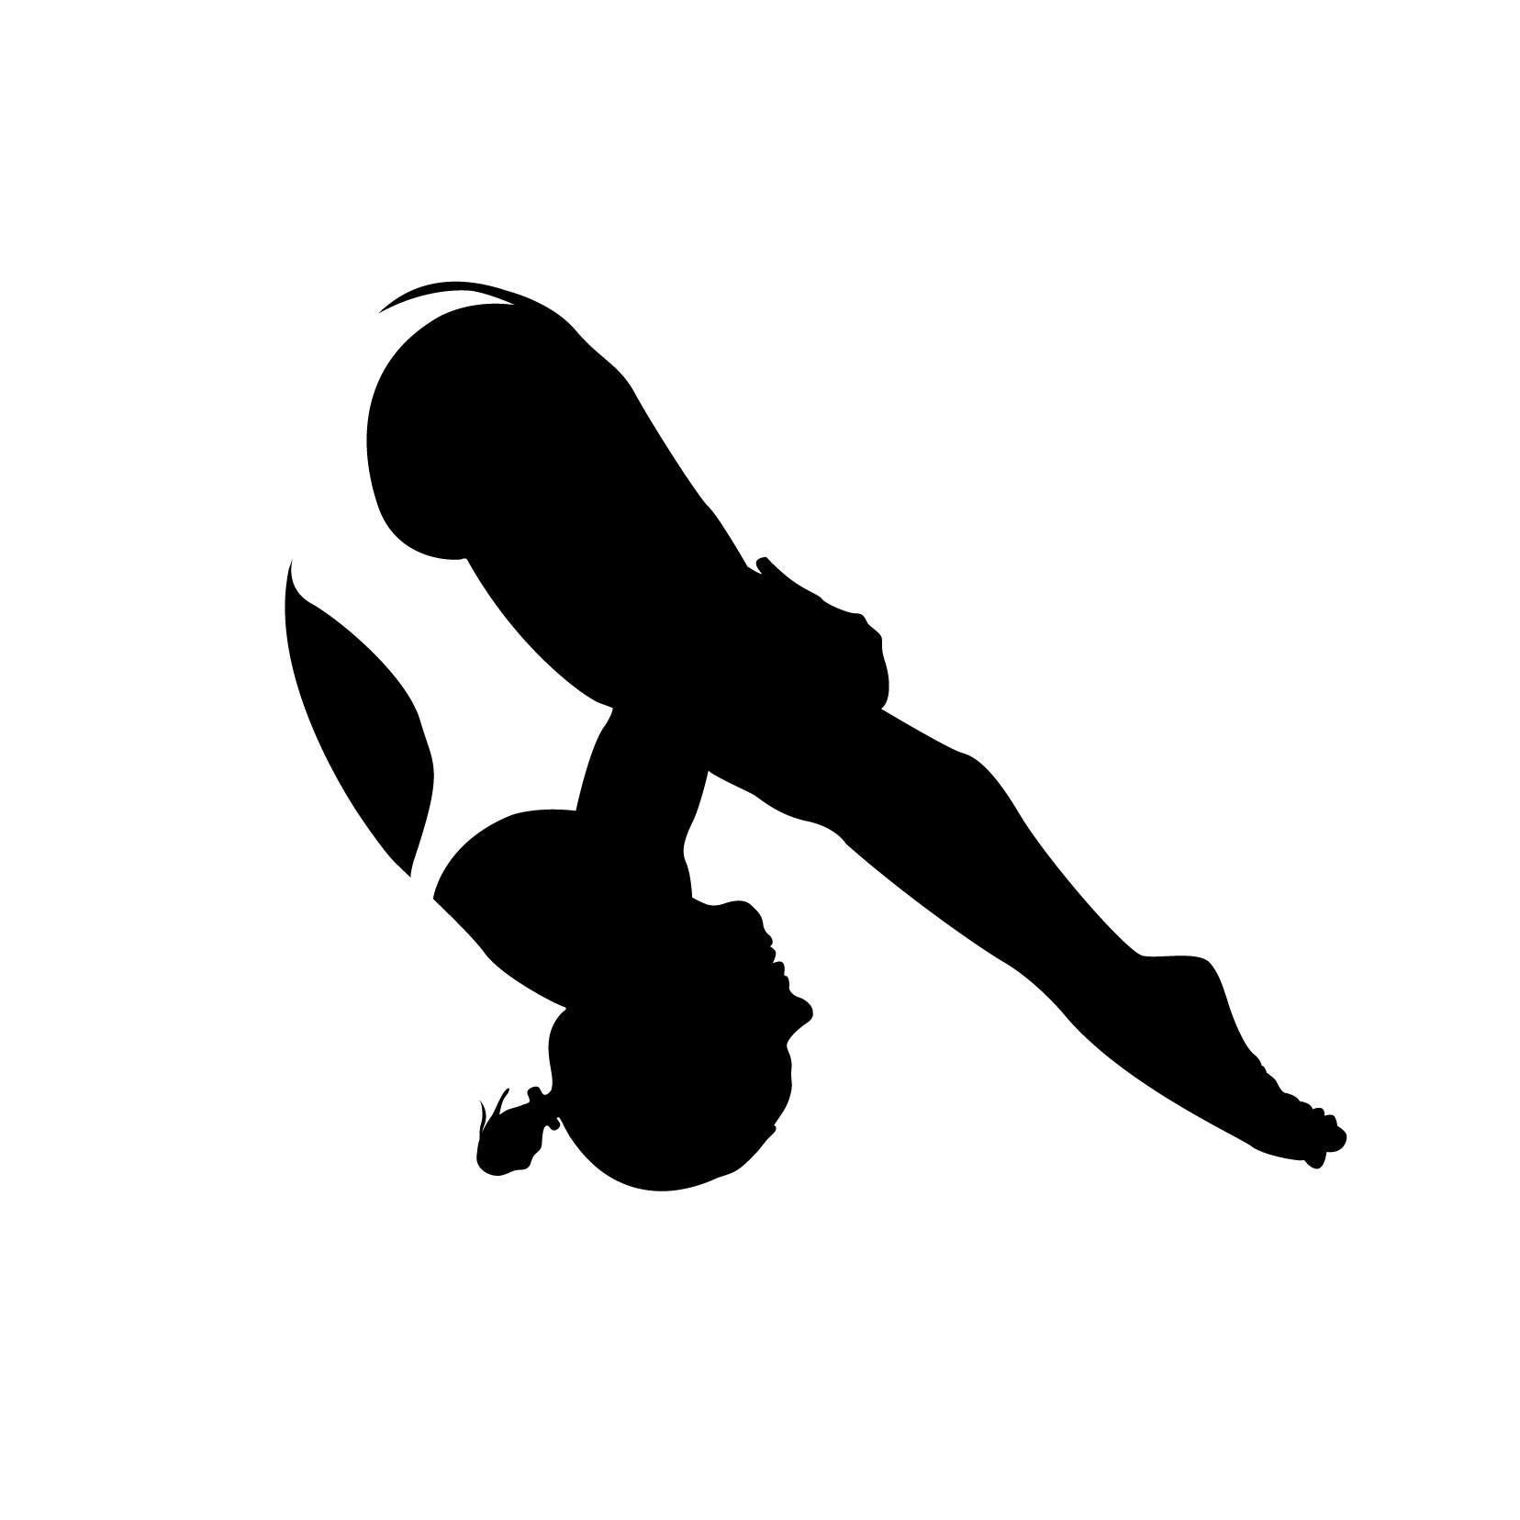

**COME-OUTS –** repeat x 8

**Pike-outs**

* On a mat start in a Tuck Position
* Roll back, then forwards, waiting until just past vertical kicking legs out straight out in front with arms to a “T” and hands touching the ground, and the nose to the knees.
* Lift upper body to hollow entry grab, just short of vertical

**Candle Sticks**

* On a mat start in a Tuck Position with head down and looking at toes.
* Roll back, kicking out slightly less then vertical, pushing hip up, hands on the top of thighs, and looking at toes (do not kick out past vertical)
* Return back into tuck position

**Wall Entries**

* **Beginner** – Facing wall, about 12 – 18 inches away, start in entry position with arms over head. Go up on toes and press hands against wall in tall, hollow, entry line.
* **Advanced** - Facing away from wall, place hands on ground and walk feet up wall to entry position armstand, walking hands about 1 ½ - 2 feet from wall.
* Hollow line, butt tight, looking at hands

**ONE-STEP HURDLE FRONT DIVE PIKE**

* Using 8 steps combine the One-step Hurdle and Pike entry.
* Go through the steps slowly, the pick up the pace.
* Note – you do not jump after the hurdle; just extend to the reach position before going into the pike.

**ONE-STEP HURDLES**

* You can use a small rectangular mat to simulate a diving board, or a line to represent the end of the board.
* Eyes should be focused on the end of the board in the hurdle (without dropping the head), and a few feet in front in the jump.

***Look where you are going to leap.***

**Make sure the area is dry to prevent slipping**

Start from Ready Position

1. Arms move slightly forward
2. Lunge step forward with body tall not leaning forward, arms swing slightly back
3. Knee comes up to 90° angle (make sure the foot does not go out in front on the knee), arms come up to reach, and hop to two feet landing in reach position at end of mat. Pause in the Reach Position.

*You can eliminate the jump by dropping hurdle foot to floor beside stable foot and extend the reach.*

1. Swing and a jump (or swing and extend) landing in the Reach Position. Hold reach.

Repeat 12 times, the first 4 pausing at each step, then 4 faster pausing at step 3, then 4 without a pause making sure to holds the arms in the reach during the hurdle.

**No windmill arms!** These are big circle arms swings not stopping in the reach in Step 3.

**ADDITIONAL EXERCISES**

**Seated Pike Stretch**

* Sit on floor/mat with legs straight out, back flat and arms in reach position
* Bend forward at waist with flat back as far as possible before rounding back and trying to touch toes
* Hold for 20 – 30 seconds
* Repeat flatfooted and with toes pointed

**Plank**

* Lying flat on stomach, raise up to plank position with elbows in line with shoulders, back flat and core tight
* Hold for 30 – 60 seconds

**Superman Entry Stretch**

**Back**

* Lay flat on your stomach with arms stretched over head
* Extend to an entry stretch; arms squeezing ears, hands in entry grab, butt tight, raise shoulders and feet to slight arch

**Front**

* Lay flat on your back with arms stretched over head
* Extend to an entry stretch; arms squeezing ears, hands in entry grab, core tight, back flat to mat in “hollow position”, toes pointed, and heels just off floor

**Hold for 10 – 20 seconds. Repeat 2x each**

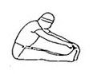

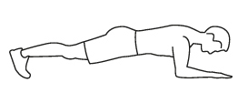

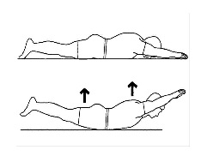

**One-Step Hurdle Diagram**

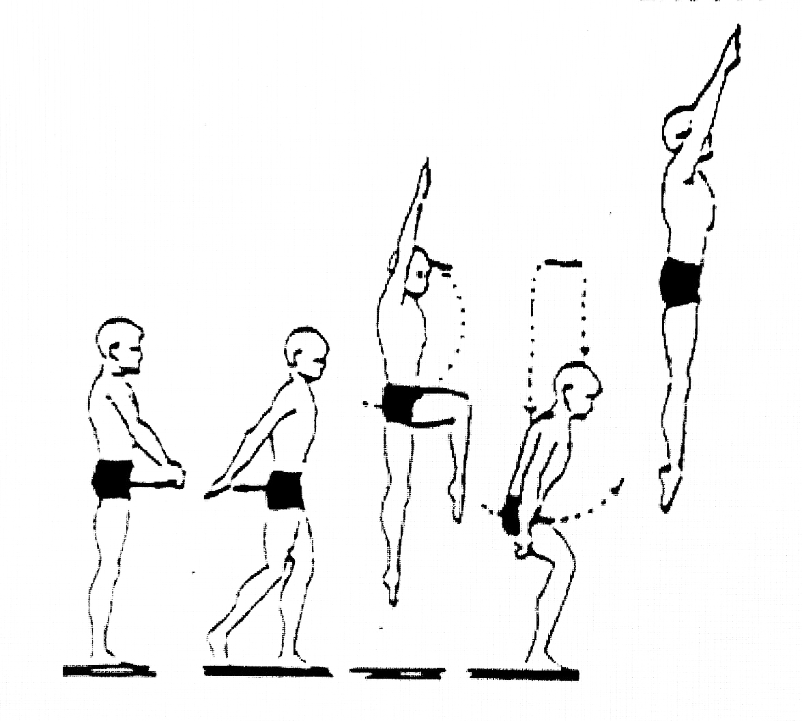

**ADDITIONAL EXERCISES AND DRILLS**

**Crunch**

* Lay on back with knees bent, feet on floor, and hands on front of thighs
* Walk fingers up to knees and hold 3 – 5 seconds
* Walk finger slowly down to flat back
* Repeat x 10 - 20

**Reverse Crunch** (I use this instead of pike-ups as they are easier on the lower back. This also helps simulate the action needed in initiating lower body rotation for back and reverse spinning dives)

* Lay on back on a mat in reach position
* Bend knees and raise feet up to a little more than 90° angle
* Pull knees to chest raising hips up into a reverse crunch
* Lower back down
* Repeat x 10 – 20

This can also be done pike

starting flat on mat in reach

position and raising legs

straight bringing toes to

hands (or as close as

possible), with arms still

in reach and on the mat.

Arms should be in reach position

**JACKKNIFES –** not recommended if you live in an upper floor condo/apartment

This skill is useful for forward and inward rotating dives

Use a sturdy bench or box between knee and waist height for this drill.

* Start from the reach position
* Bend at the waist and place hands on the surface top
* Using the legs and feet push off the ground and raise hips to a pike position with the legs straight
* The eyes should be focused on either the hands or the feet

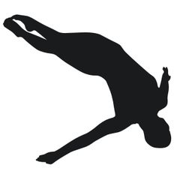

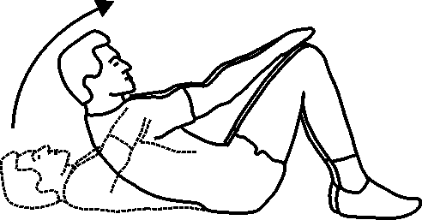

**Resources and Video Links**

These are some of the resources that I find helpful and show good examples of the skills and techniques you can use while practicing the exercises in this handout.

Please feel free to share any examples or links you may like.

**Take-offs and Hurdles**

-Hurdles

<https://www.youtube.com/watch?v=394jP9gyttw&t=247s>

-Back Take-offs (similar technique for standing front Take-offs

<https://www.youtube.com/watch?v=zr5d4O0zcFg>

**Entries**

<https://www.youtube.com/watch?v=8Jn1WOHLZpU>

<https://www.youtube.com/watch?v=GqZQU4N9WlE>

**Positions**

<https://www.youtube.com/watch?v=9LfEbcUH4R0>

**Initiating the Throw for Forwards/Inwards**

<https://www.youtube.com/watch?v=sahQLegLrJo>

**Tips and Tutorials**

<https://www.youtube.com/playlist?list=PLfdRWJDIq1O0OV_Yeg3jx129cvtkFmeKU>

