**Saturday, December 14, 2014**

**8 am – 11:30 pm**

**Follow up sessions;**

**8 – 10 am, Saturday**

**January 10 & 24, 2015**

**Vancouver Aquatic Center**

**1050 Beach Ave, Vancouver, BC**

For more information or to register please contact:

**Jayne MacDonald**

**Ph: 604-531-5576**

[**www.bcdiving.ca**](http://www.bcdiving.ca)

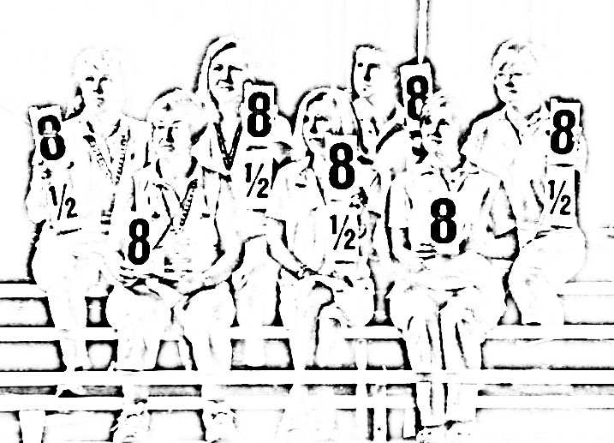

**Introduction to Judging Clinic**

This Introduction to Judging clinic will be divided into two parts:

* The first 2 hour section will be General Information. This section is open to all, and would be beneficial to those parents interested in gaining a better understanding on how diving competitions are run. It will cover dive sheet information, dive numbers, dive groups, dive positions, DD formula, and competition set-up.
* The second 2 hour section is for those who are interested in entering into the Officials Program and Coaches, and will cover duties of the referee and assistant referee, judging the dive, and summary of penalties.

**This clinic is a mandatory review for our registered Regional/ Provincial Level Officials.**

Follow-up will be 8 – 10 am Saturday January 10 and 24, 2014; and will focus on judging the dive, including on-deck practice judging.

**Course conductors: Al Hungerschafer and Bev Boys**

Fall 2014

Officials Clinic

