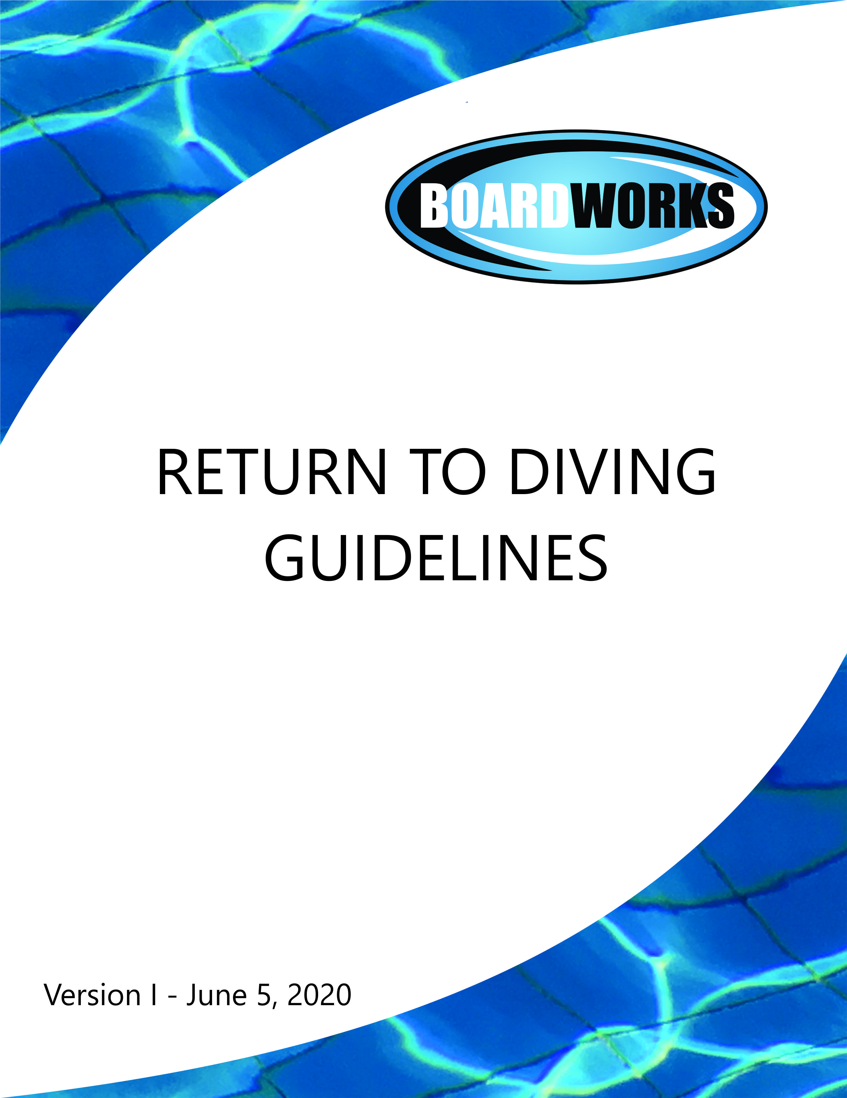

CONTENTS
Procedures to ensure a safe training environment .............................................................2
Accessing the Facility ...........................................................................................................2
Safety Measures...................................................................................................................4
Program Management ........................................................................................................5
Safeguarding........................................................................................................................6
First Aid…………………………………………………………………………………………………………………………….8
Communications Plan .........................................................................................................8
Appendix A: Daily Health Screening ……………………………………………………………………………..….9
Attachment A: Diving Plongeon Canada Informed Consent & Assumption of Risk Agreement
Attachment B: Diving Plongeon Canada Declaration of Compliance – Covid-19
Attachment C: Diving Plongeon Canada Release of Liability, Waiver and Indemnity Agreement

PROCEDURES & PROTOCOLS TO ENSURE A SAFE TRAINING ENVIRONMENT
Following the guidelines set out by Diving Plongeon Canada, ViaSport and BC Diving, enclosed are the Return to Diving policies, procedures and protocols for athletes, staff and parents of Boardworks (aka Pacific Coast Diving). These policies, procedures and protocols are precautionary measures to prevent the spread of Covid-19 and must be adhered to by all Boardworks athletes, staff and parents/guardians.

ACCESSING THE FACILITY (SCP)/OUTDOOR TRAINING AREA
1. Anyone feeling unwell must stay home.
2. Each athlete and staff member must sign the attached “Informed Consent & Assumption of Risk Agreement”, “Declaration of Compliance – Covid-19” and “Release of Liability, Waiver and Indemnity Agreement” acknowledging their acceptance of the risks prior to returning to training (see Attachments A, B & C). All three documents have been provided to us by Diving Plongeon Canada.
3. Each athlete or staff member entering the facility/outdoor training area must respond to a series of health questions upon arrival to each practice (see Appendix A).
4. Athletes will be allowed to enter the facility/outdoor training area only during their designated training time.
5. Parents/guardians are not permitted in the designated outdoor training area or inside Saanich Commonwealth Place (“SCP”).
6. When possible, team members should use private transportation and avoid carpooling.
i. Travel to the pool for training will be direct with no non-essential stops. ii. If a private vehicle is not available, individuals must wear gloves and a mask while using public transportation.
7. Boardworks athletes will enter and exit SCP through the following access points:
i. upper rear doors by the dryboards for dryland access
ii. Lower rear door by the 1 metre boards for pool access
8. Boardworks athletes and coaching staff will be allowed to access the lower bathrooms under the dryland area only. No other changerooms or bathrooms are permitted to be used by Boardworks athletes or coaching staff in SCP.

9. Boardworks athletes and coaching staff will follow handwashing, sanitizing and physical distancing protocols in all training areas including dryland, bathrooms and pool deck.
10. Any outerwear (including footwear) worn upon arrival to the training facility must be removed and placed inside a plastic bag (brought by the athlete) inside their backpack.
11. Only clothing and equipment required for training purposes will be brought to the training sites.
12. Boardworks athletes are not permitted to use the hot tub, sauna or steam room at SCP.

SAFETY MEASURES
1. Athletes/coaches/staff will wash hands upon entering the training facility. Soap and water or liquid disinfectant will be made available in each training area (dryland & pool area) for athletes and coaching staff to use regularly.
2. When the use of a mask throughout this document is mentioned, it is intended that it must be a NEW disposable mask or a CLEAN reusable mask (or face covering). Reusable masks must be washed daily in order to be re-used or renewed.
3. Coaching staff and staff should wear masks while working when proper social distancing is not possible.
4. Athletes will bring a clearly marked bag with clothing, towel, chamois, equipment and full water bottle. Depending on facility rules, these will be left at a designated area. No items are to be shared by divers at any time. This designated area will be cleaned after each use.
5. All team members and coaching staff will maintain a distance of 2 metres from other individuals. Athletes that require a physical interaction (ie. Hand spotting and certain flexibility) can do so only when appropriate protective gear and masks as specified by the facility are worn by both individuals.
6. Athletes and coaching staff should be instructed with any emerging safety and cleaning guidelines.
7. Coaching staff will be responsible for cleaning areas and equipment after each user.

9. Appropriate protective equipment is required for people cleaning equipment between rotations or at the end of day, and hands need to be washed between each new set of gloves.

PROGRAM MANAGEMENT
1. Boardworks will adhere to maximum allowable numbers as dictated by the local government and facility policies.
2. Training at SCP will start based on the schedule approved by SCP:
a. Maximum number of athletes in each session will not exceed 8 but is at the discretion
of the coaching staff
b. Phase I of training will be small group outdoor dryland training at selected outdoor training
locations and is open to all athletes on the Boardworks competitive team
c. Phase II of training at SCP will be limited to High Performance athletes (“High Performance” at SCP is defined as anyone having achieved the junior or senior national qualifying standards)
c. Phase III of training at SCP will include Provincial level athletes
d. Phase IV of training will include developmental programs
3. Boardworks will maintain a detailed log recording all participants (athletes, coaches, staff) present at every workout. This log can be used for tracing in the case of a member of the group contracting COVID-19.
4. The use of the mats / trampolines / dryboards:
a. 2 metres per person will always be maintained.
b. Use of equipment will be restricted to one person at a time
c. Surface areas are to be wiped with disinfectant after each user.
d. When possible, training equipment will be allocated to one or two individuals maximum. Only those individuals will use the specified equipment. Example: A folding mat will be shared by two individuals but must still be cleaned between the use of each individual.
5. Diving Pool Area:
a. Divers will remain 2 metres apart while waiting to dive
b. All other divers will wait on the stairs or on the pool deck and will remain 2 metres apart
c. Markers will be placed on the floor and stairs leading to the springboards and platforms to ensure 2 metre distances are maintained.

6. Spotting Rig Harness Use:
a. Divers who can safely secure their harness will do so. In other cases, the coach will assist while wearing protective clothing.
b. The harness and ropes will be cleaned after each use with disinfectant.

SAFEGUARDING
1. Inform coaching staff immediately if, you feel any symptoms of COVID-19 such as fever, chills, cough, shortness of breath, sore throat and painful swallowing, stuffy or runny nose, loss of sense of smell, headache, muscle aches, fatigue and loss of appetite.
2. Assessment
a. Athletes or coaching staff must complete health questionnaire before their practice to attest that they are not feeling any of the COVID- 19 symptoms.
b. Coaching staff will visually monitor athletes/coaching staff to assess any early warning signs as to the status of their health and to touch base on how they are regarding their personal safety throughout the workday/practice.
c. If athletes or coaching staff are unsure please use the self-assessment tool
https://bc.thrive.health/covid19/en
or through the COVID-19 BC Support App self assessment tool.
3. If an athlete or coaching staff is feeling sick with COVID-19 symptoms
a. They should remain at home and contact Health Link BC at 8-1-1.
b. If they feel sick and /or are showing symptoms while at practice/work, they should be sent home immediately and have them contact 8-1-1 or a doctor for further guidance.
c. No athlete or coaching staff may participate in a practice/activity if they are symptomatic.

4. If an athlete or coaching staff tests positive for COVID-19
a. they will not be permitted to return to the practice/facility until they are free of the COVID-19 virus.
b. Any athlete or coaching staff who are part of the infected athlete or coach staff’s training group will also be removed from the workplace/practice/facility for at least 14 days to ensure the infection does not spread further.
c. Boardworks will close off, clean and disinfect their work/practice/facility area immediately and any surfaces that could have potentially be infected/touched.
5. If an athlete or coaching staff has been tested and is waiting for the results of a COVID-19 Test
a. As with the confirmed case, the athlete/coaching staff must be removed from the practice/facility.
b. The Public Health Agency of Canada advises that any person who has even mild symptoms to stay home and call the public health authority of B.C.
c. Other athletes or coaching staff who may have been exposed will be informed and removed from the workplace/practice/activity for at least 14 days or until the diagnosis of COVID-19 is ruled out by health authorities.
d. The practice space will be closed off, cleaned, and disinfected immediately and any other surfaces that could have potentially been infected/touched.
6. If an athlete or coaching staff has come in to contact with someone who is confirmed to have
COVID-19
a. Athletes and coaching staff must advise their coach/employer if they reasonably believe they have been exposed to COVID-19.
b. Once the contact is confirmed, the athlete or coaching staff will be removed from the workplace/practice/activity for at least 14 days or as otherwise directed by public health authorities. Athletes or coaching staff who may have come into close contact with the infected athlete/coach will also be removed from the workplace for at least 14 days.
c. The training area will be closed off, cleaned, and disinfected immediately and any other surfaces that could have potentially been infected/touched.

7. Quarantine or Self-Isolate if:
a. Any athlete or coaching staff has travelled outside of Canada within the last 14 days is not permitted to enter any part of the facility and must quarantine and self-isolate.
b. Any athlete or coaching staff with any symptoms of COVID-19 is not permitted to enter any part of the facility and must quarantine and self-isolate.
c. Any athlete or coaching staff from a household with someone showing symptoms of COVID- 19 is not permitted to enter any part of the facility and must quarantine and self-isolate.
d. Any athlete or coaching staff who is in quarantine or self-isolating as a result of contact with an infected person or in families who are self-isolating, is not permitted to enter any part of the facility.
FIRST AID
1. First aid while training at SCP will continue to be offered by SCP lifeguard staff, who will follow Provincial and National lifeguard standards and policies and BC Provincial Health Guidelines.
2. Boardworks coaching staff will have masks and gloves available as “first-responders” in first-aid situations.
COMMUNICATIONS PLAN
Boardworks will continue to provide ongoing, accurate and current information to its members and coaching staff via email updates.

APPENDIX A –DAILY HEALTH QUESTIONNAIRE
The following questions will be asked and recorded prior to the start of each training session:
1. Are you experiencing any symptoms of COVID-19 such as:
- fever
- chills
- cough
- shortness of breath
- sore throat and painful swallowing
- stuffy or runny nose
- loss of sense of smell
- headache
- muscle aches
- fatigue
- loss of appetite
2. Has anyone in your immediate family/household experienced any of the above symptoms?
3. Has anyone in your immediate family/household currently self-isolating/quarantining
3. Have you travelled outside Canada within the past 14 days?
4. Has anyone in your immediate family/household travelled outside Canada within the past 14 days?

