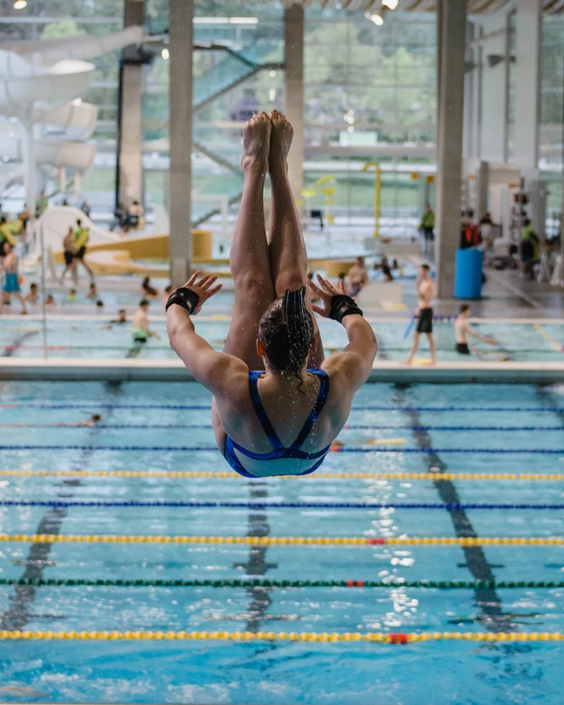
BC DIVING
presents
2024 BRITISH COLUMBIA
WINTER PROVINCIAL DIVING CHAMPIONSHIPS

February 2-4, 2024
Grandview Heights Aquatic Centre

Surrey, BC
CANADA

Meet Manager Jayne McDonald
Phone: (604)531-5576 Email: edbcdiving@gmail.com

Technical Igor Kopecky
hptdbcdiving@gmail.com

Dates Friday, Feb 2, Sat. Feb. 3, & Sunday, Feb 4, 2024

Host & Venue BC Diving – Grandview Heights Aquatic Centre
16855 24 Ave.
Surrey, British Columbia
604-531-5576

Facility 4 - 1 metre springboards (2 Competition boards)
Two 3 metre springboards
Platform complex with 1, 3, 5, 7.5, and 10 metre platforms

Sanctioned by: Diving Plongeon Canada/BC Diving
2024 National Jr. Qualifier, 2023 Sr. National Qualifier

Eligibility & Rules All Diving Plongeon Canada, USA Diving or other registered members of Federations affiliated with FINA divers may attend. (Per FINA Rule GR 3.1, all entries received from outside Canada must be a member of a FINA-affiliated
organization. This applies to athletes, coaches, officials and any
other team members).
Age-group determination is the diver's age as of December 31st,
2024

Diving Plongeon Canada rules will apply to all events. Please see below for a summary of the rules for all events. This is a Junior & Senior National Qualifying event.

Events may run up to 1 hour ahead of the scheduled and posted times. A revised final schedule will be distributed upon the arrival of the teams.
Divers may only dive one age group with the following exceptions: E group divers may compete in D springboard and platform events.

Finals dive sheets must be on separate dive sheets.

Each club must ensure dive sheets are sent in electronically prior to Friday, Feb. 2. If not possible – all dive sheets must be handed to secretary on the Friday.

Entries All entries must be received no later than Monday, January 22, 2024. Entries may be e-mailed to:

BC Diving
Email:edbcdiving@gmail.com

Entry Fees $50.00 Cdn Diver Registration Fee (includes $10 official’s fee)
$50.00 Cdn Event Fee per event.
Deck Entries are $60.00 Cdn per event per diver. Deck entries will
be accepted up until one hour prior to the beginning of the event.
Qualifying events & finals are considered one event. (i.e. divers do
not pay to enter final event)

Dive Sheets All dive sheets must be submitted electronically using Dive Sheet Generator. Dive sheets must be submitted 24 hours prior to the event. To download a copy of Dive Sheet Generator, please visit http://www.integratedsports.net/diving/ds_download_diver_canada.html.

Email electronic Dive Sheets to: sven.batalla@shaw.ca

It is recommended that you bring an electronic copy of the most recent file that you uploaded to the competition. If there are any problems the host committee can transfer the file containing your dive sheets via a USB key.

Awards Medals for the top three.
Ribbons for 4th to 6th place.
No medals or ribbons will be awarded in National qualification
events. (D1,D2,C1,C2)

COMPETITION RULES:

General

The BC Diving Winter Provincials will follow the 2024 Canadian Junior and Senior National Dive Requirements for Groups A, B, C & D & Open. The Preliminary events in Groups C1, C2 & D1 & D2 will be the National Qualifying event (NQ). Only divers who meet all the requirements may enter their respective age group event preliminary event. There will also be a final for Groups C & D which will be the Provincial Championship event (PC).

Group A & B will follow the Junior National Dive Requirements. A & B groups will be a straight final at the Winter Provincials.

The Beauty and the Beast.

Prior to the competition divers will identify which 5 dives that will count towards this competition. The same five dives count in both rankings. One dive from each group (platform divers may replace any group with a handstand dive). You may choose dives from different events ie. Your list could be 10m 107B, 3m 205C, 3m, 301B, 1m 401B, 10m 5253B.
These five dives will then be used to determine two different rankings.
Raw score/Beauty rankings-Only raw judges scores are totalled to determine this rank.
With DD/Beast rankings- The total points including the DD will be used to rank divers for this.

At the end of the competition all divers participating Beauty and Beast will receive one final ranking which combines placement ranking in Beauty plus placement ranking in Beast to get an overall ranking. i.e.. 1st in Beauty and 3rd in Beast = 4 total points- lowest total is the winner etc.

GROUP E EVENTS
Age: 9 years and under on December 31st of the year of the competition. Age specification: born 2015 or later.
BOYS & GIRLS GROUP E PRELIMINARIES DIVE CHART
E – 1m |  |  |  | E – 3m
Dive Order | Dive # | DD |  | Dive Order | Dive # | DD
1 | 100A | 1.8 |  | 1 | 001B | 1.9
2 | 200A | 1.8 |  | 2 | 002A | 1.9
3-6 | 4 dives selected from three (3) or more groups. All dives shall have a DD of 1.8 |  |  | 3 | 100B (with hurdle) | 1.9
 |  |  |  | 4-6 | 3 dives selected from three (3) or more  groups. All dives shall have a DD of 1.9

OPEN MEN’S & WOMENS

PROVINCIAL CHAMPIONSHIP (PC) EVENTS
1m & 3m Women | 1m & 3m Men | Platform Women | Platform Men
General:  - Divers perform five  (5) dives  - FINA DD  - All dives must be of a different dive number | General:  - Divers perform six (6) dives  - FINA DD  - All dives must be of a different dive number | General:  - Divers perform five (5) dives  - FINA DD  - All dives must be of a  different dive number  - Five (5) groups must  be represented | General:  - Divers perform six (6) dives  - FINA DD  - All dives must be of a different dive number  - Six (6) groups must  be represented

Masters Rules –

Age Groups as per FINA rules – 25-49, 50-79, 80+

Men & Women - 6 dives on any combination of 1m, 3m and/or platform – FINA D.D.
Dive numbers may be repeated only on different board categories.
Men & Women – 80+ - 3 dives, any board – FINA D.D.

See attachment for Groups D, C, B, A age group rules for 2024.

2024 BC WINTER PROVINCIALS
SCHEDULE OF EVENTS
THURSDAY, FEBRUARY 1
4:00pm – 7:00pm | Open Practice
FRIDAY, FEBRUARY 2
8:00-9:00 am | Open Practice
9:00-9:15 am | Closed Practice
9:20am |  | Girls/Boys E 3m
 | Boys A 1m |  | Girls/Boys D1 Platform
 |  |  | Girls/Boys D2 Platform
 | Girls/Boys C1 1m | Girls A 3m
 | Girls/Boys C2 1m
 |  |  | Girls/Boys D Platform Final
 | Girls/Boys C 1m Final | Girls/Boys B 3m
 | Mens Open 1m | Womens Open 3m
Practice to 5:00 pm
SATURDAY, FEBRUARY 3
7:30am – 8:25am | Open Practice
8:25am – 8:55am | Closed Practice
9:00am | Girls/Boys E 1m
 | Girls/Boys D1 1m | Girls/Boys C1 3m
 | Girls/Boys D2 1m | Girls/Boys C2 3m
 |  |  | Girls/Boys A Platform
 |  |  | Girls/Boys B Platform
 | Girls/Boys D 1m Final | Girls/Boys C 3m Final
 |  |  | Mens/Womens Open Platform
Practice to 5 pm
Awards banquet 6:00pm
SUNDAY, FEBRUARY 4
7:30am – 8:25am | Open Practice
8:25am – 8:55am | Closed Practice
9:00 am | Girls A 1m | Girls/Boys D1 3m
 |  | Girls/Boys D2 3m
 |  |  | Girls/Boys C1 Platform
 |  |  | Girls/Boys C2 Platform
 | Girls/Boys B 1m | Boys A 3m
 |  | Girls/Boys D 3m Final
 | Masters Event
 |  |  | Girls/Boys C Platform Final
 | Womens Open 1m | Mens Open 3m
*Please note 1 metre events will be on the 2 boards next to the bulkhead.

*Events will start up to 1 hour ahead of time.

BC Winter Provincial Diving Championships February 24-26, 2023
Local Hotels

Ocean Promenade Hotel
15611 Marine Dr., White Rock, BC
1-604-542-0102/855-516-1090
Deluxe two queen/deluxe king - $129
King studio - $169
One bedroom suite - $219
Apartment suite - $249
Spa suite - $299

Please inform the booking agent that you are booking for the BC Winter Provincial championships.

